**[Exercise 1: Install Jenkins of GCP server and make sure its enabled and running once installed successfully.**](https://github.com/vistasunil/CT_DevOps_WS_Module3/blob/main/Jenkins-Runbook.md" \l "exercise-1-install-jenkins-of-gcp-server-and-make-sure-its-enabled-and-running-once-installed-successfully)**

Installing Jenkins

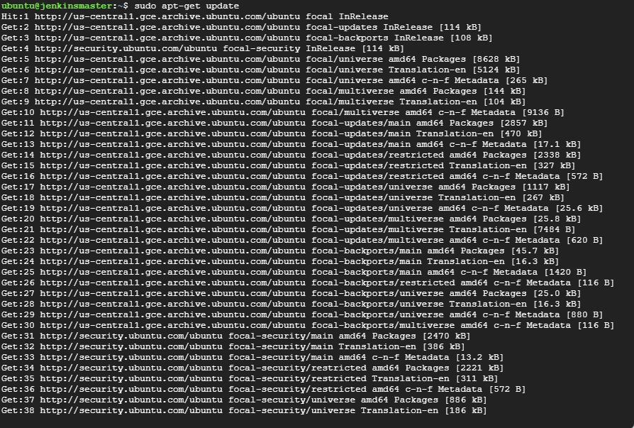

Java insalled

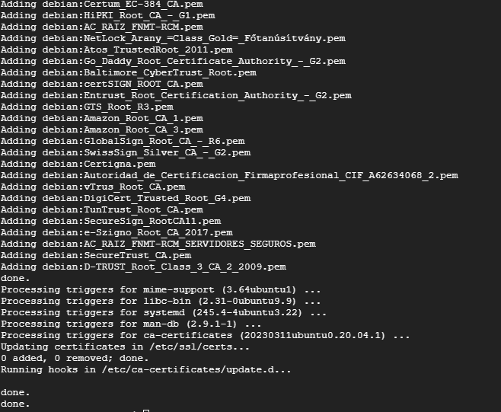





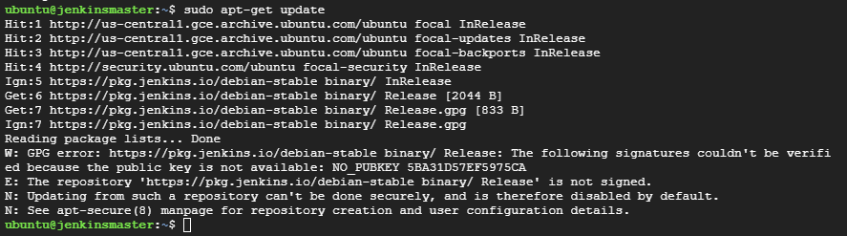

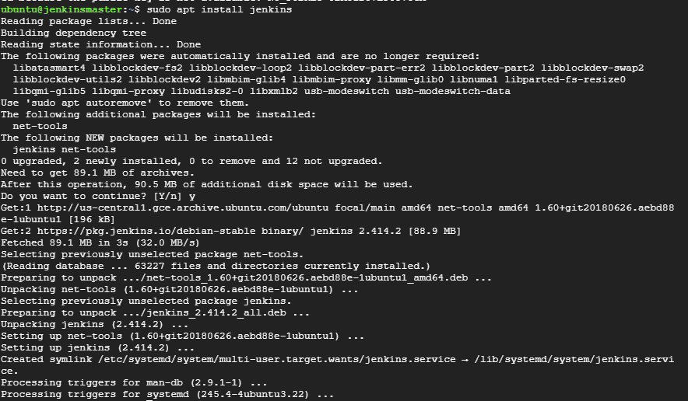

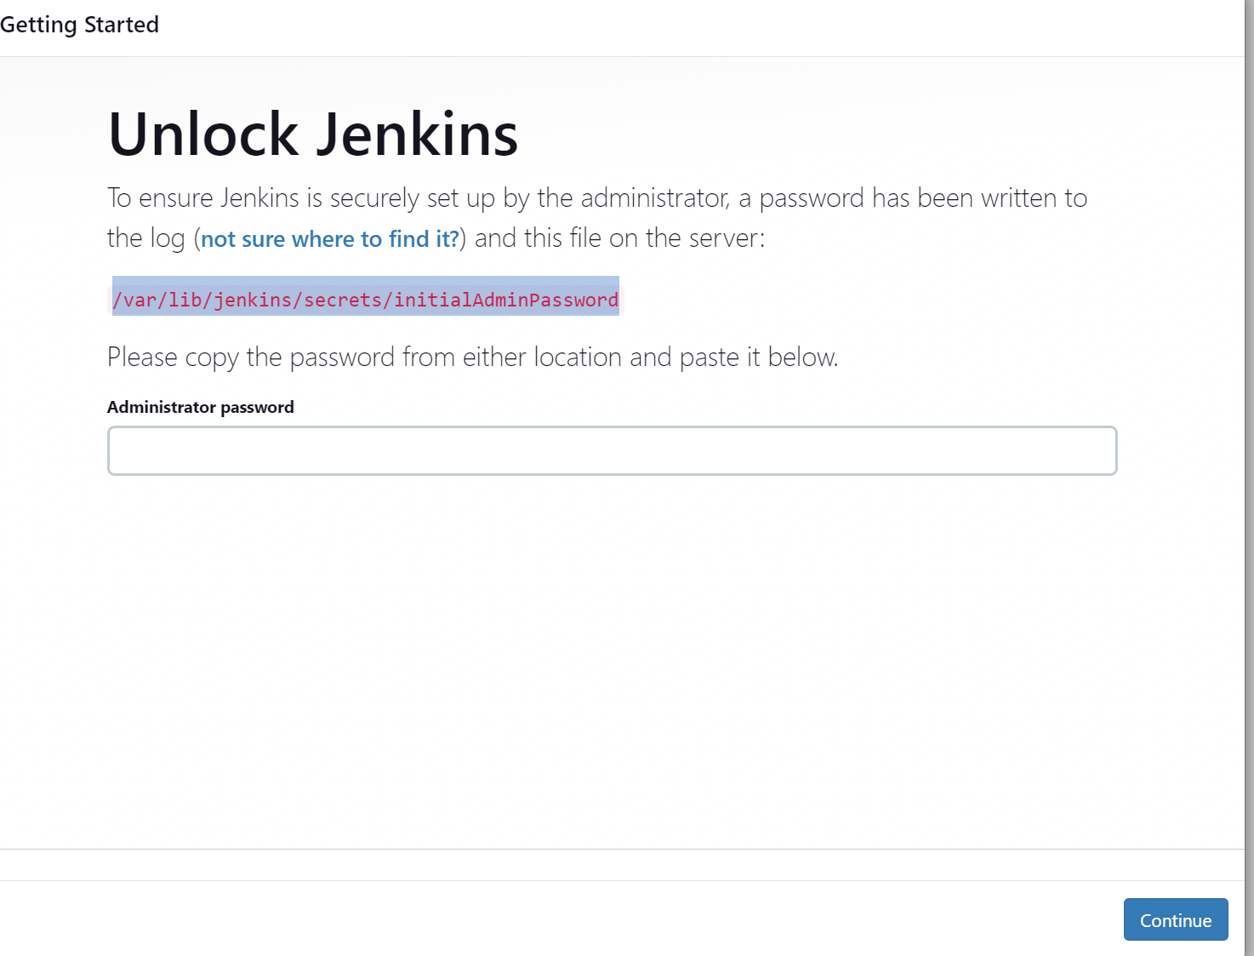

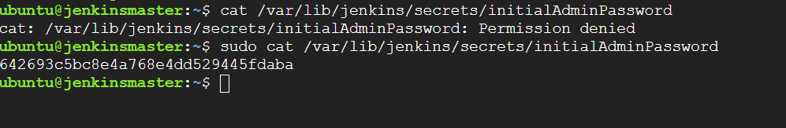

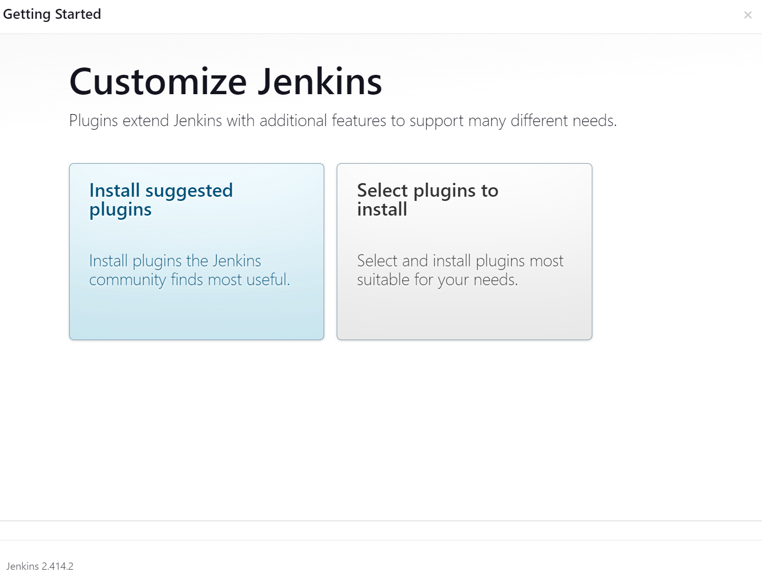

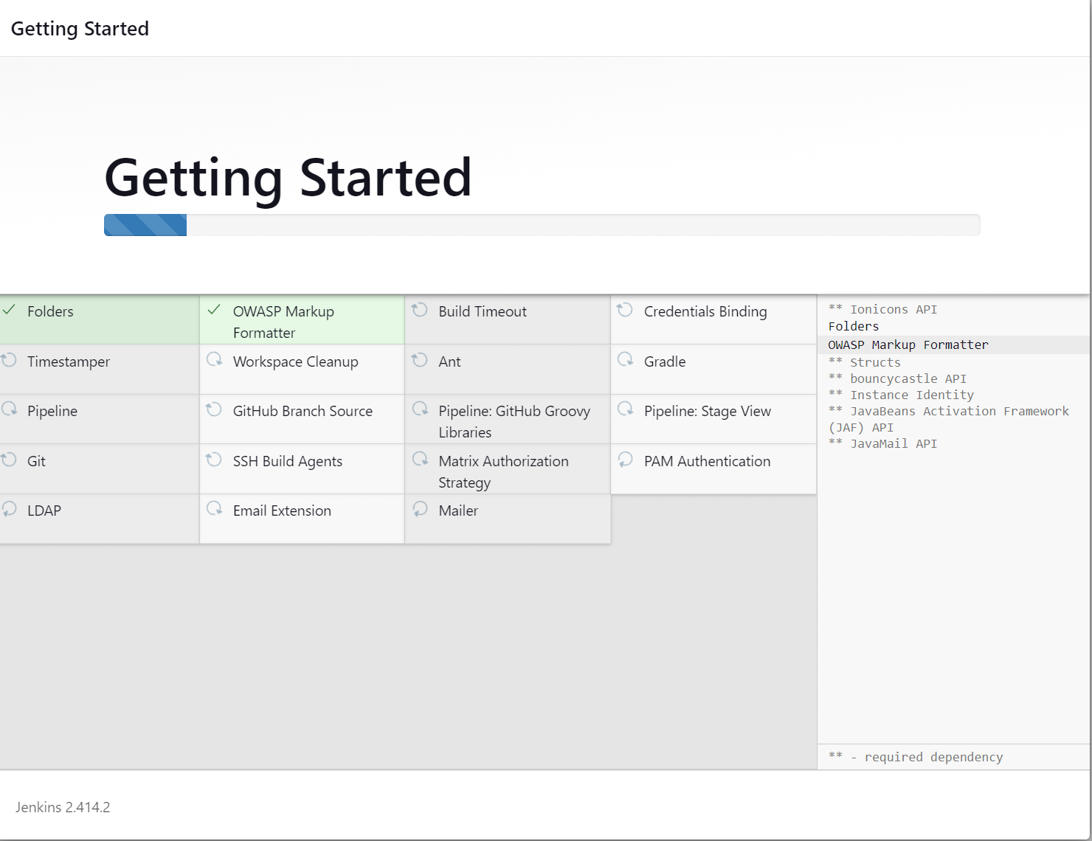

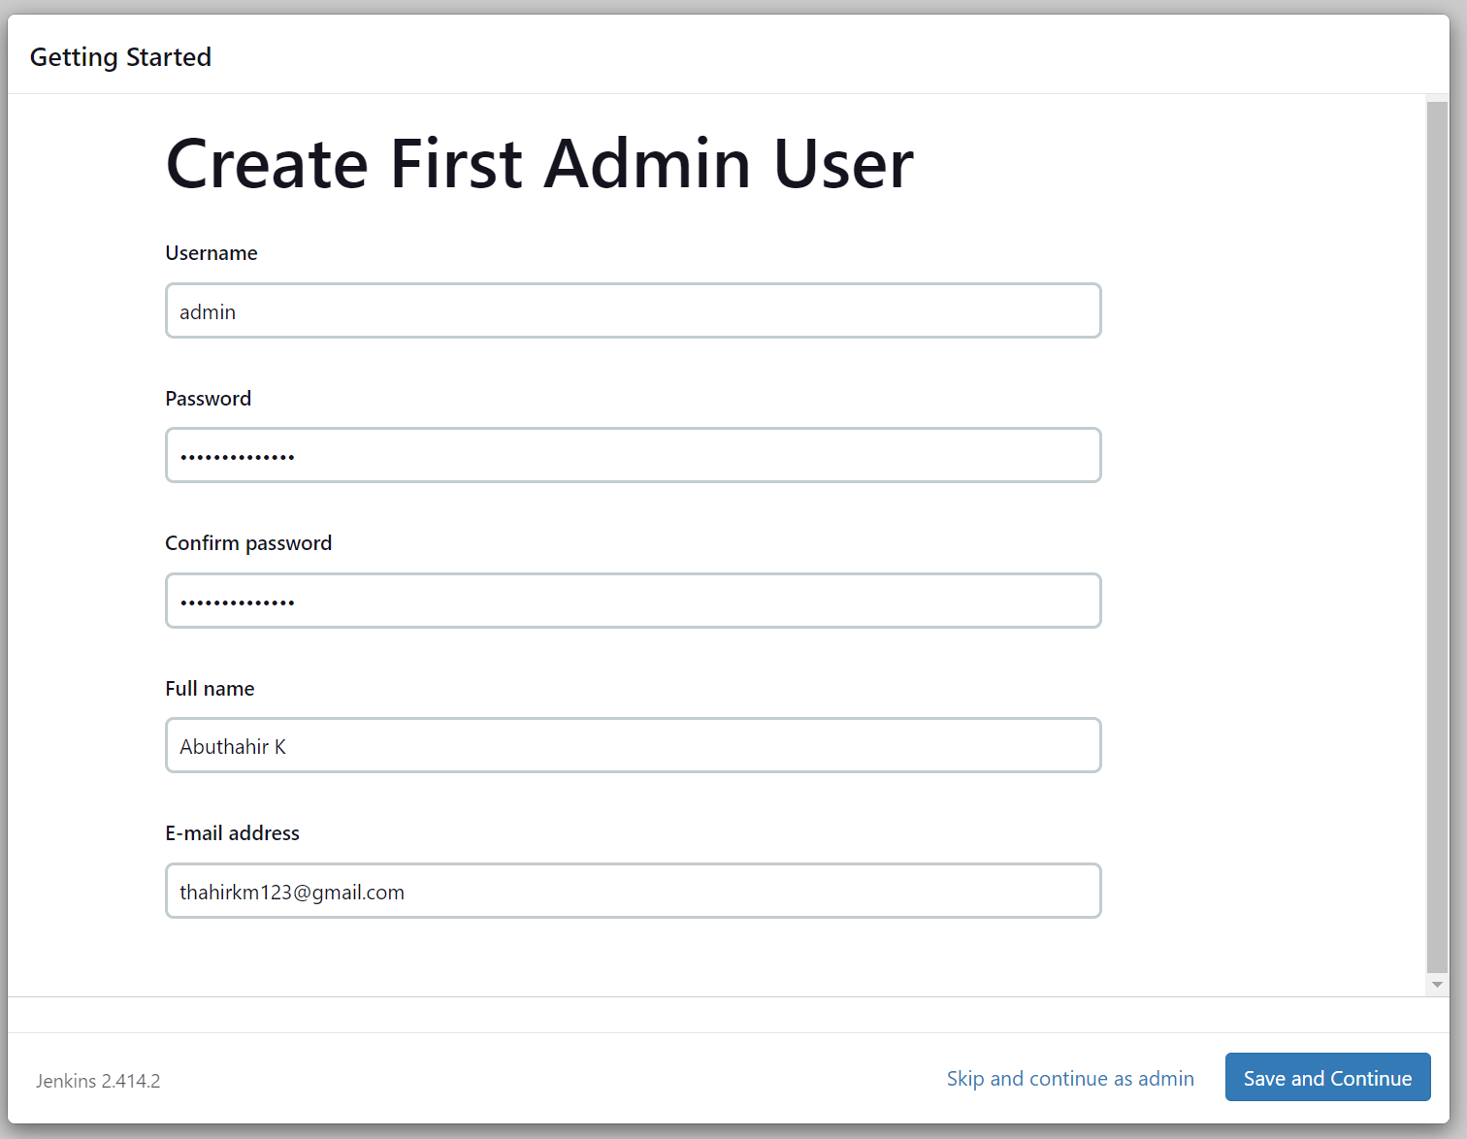

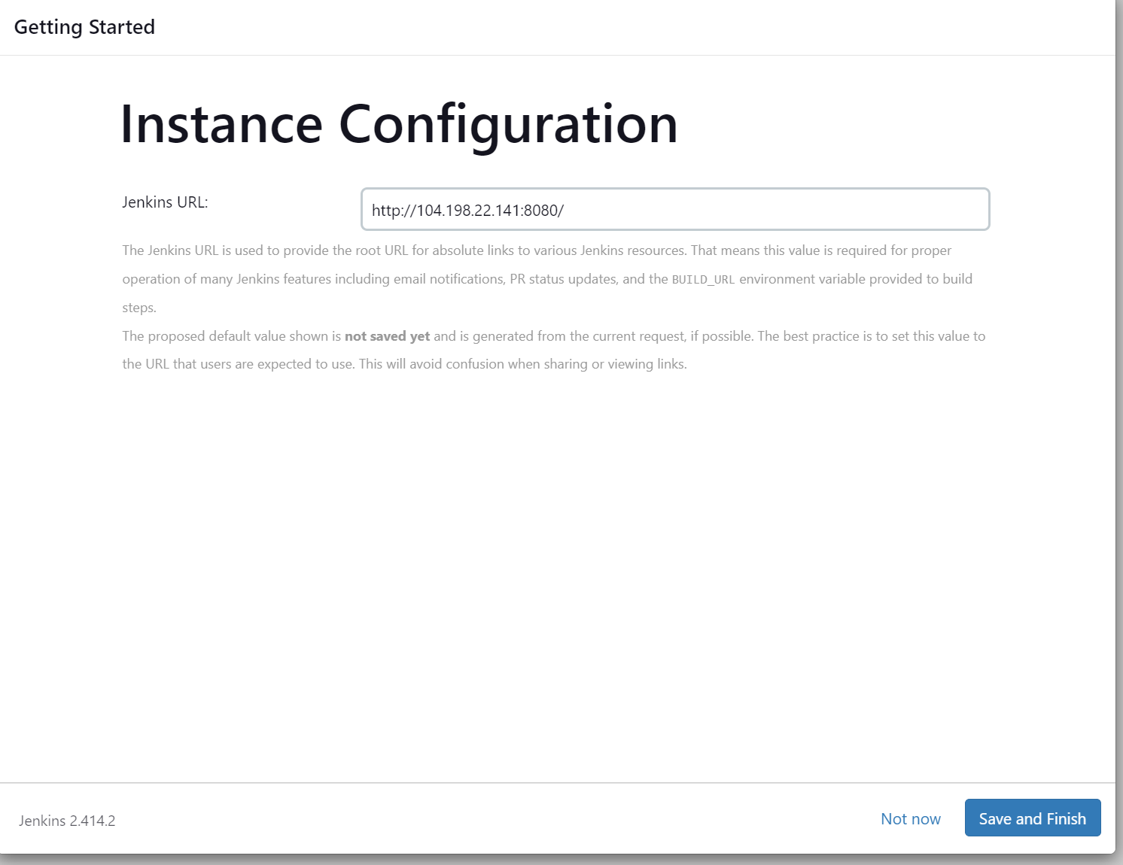

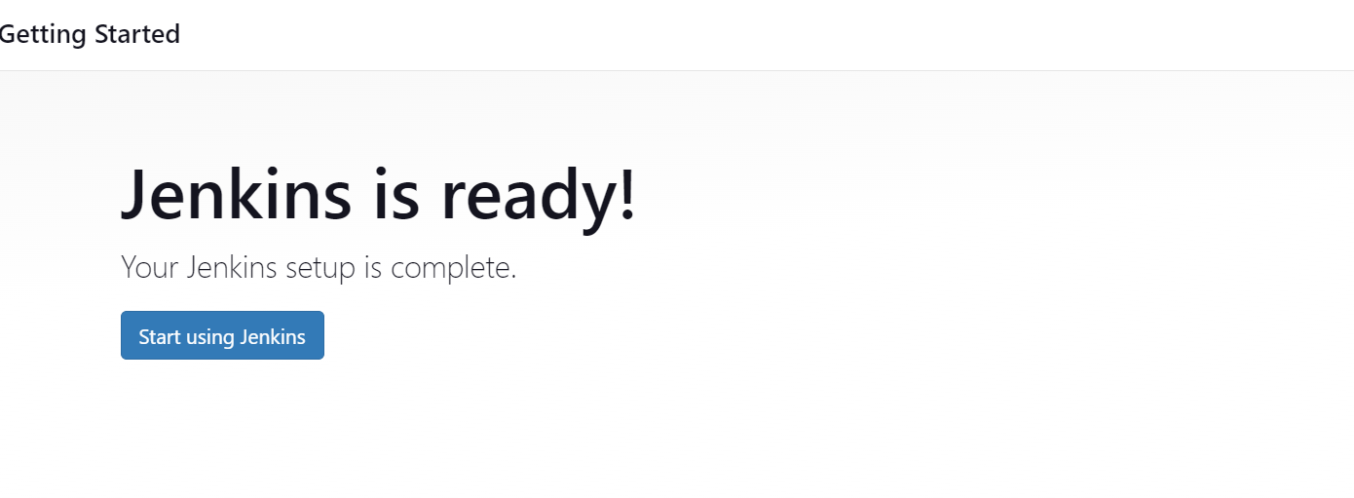

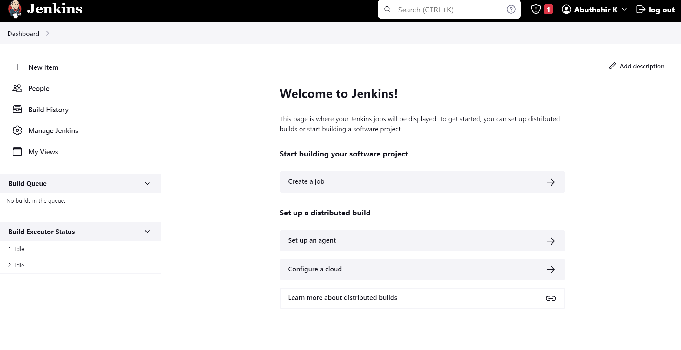

### [b). ***Configure Slave nodes***](https://github.com/vistasunil/CT_DevOps_WS_Module3/blob/main/Jenkins-Runbook.md#b-configure-slave-nodes)

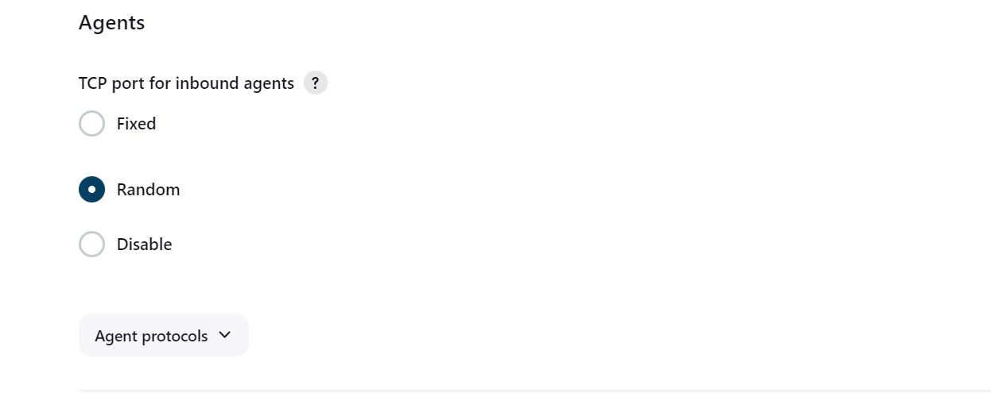

Now go to Manage Nodes.

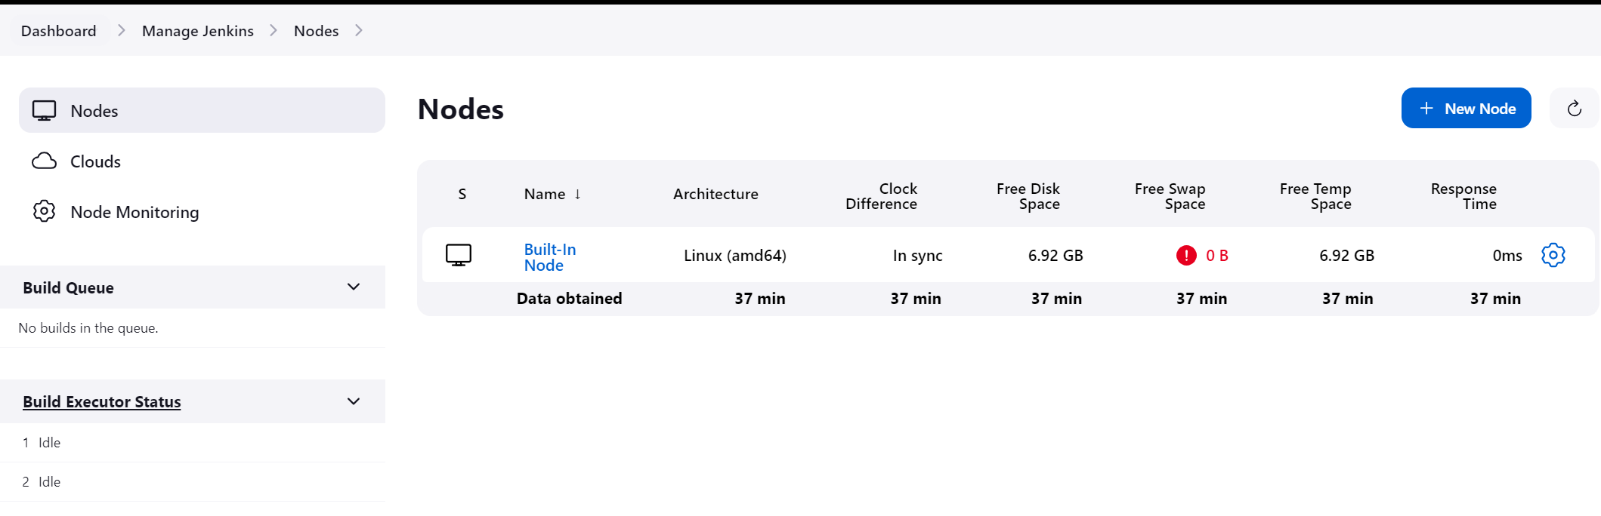

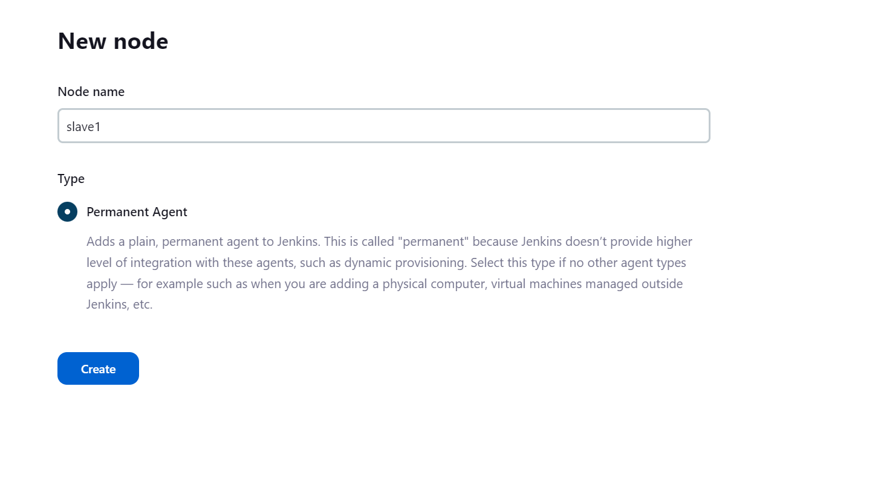

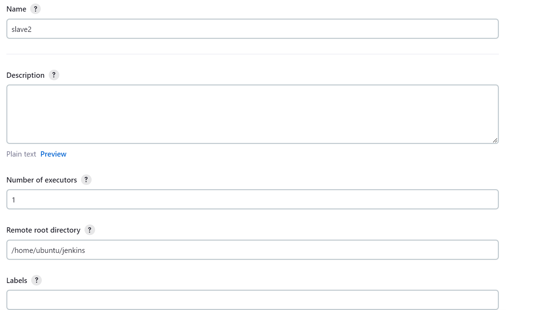

1. Create a Jenkins job to clone repo [*https://github.com/vistasunil/devopsIQ*](https://github.com/vistasunil/devopsIQ) and deploy the website inside it the slave instance in container.

ii. Install docker on both Slave1

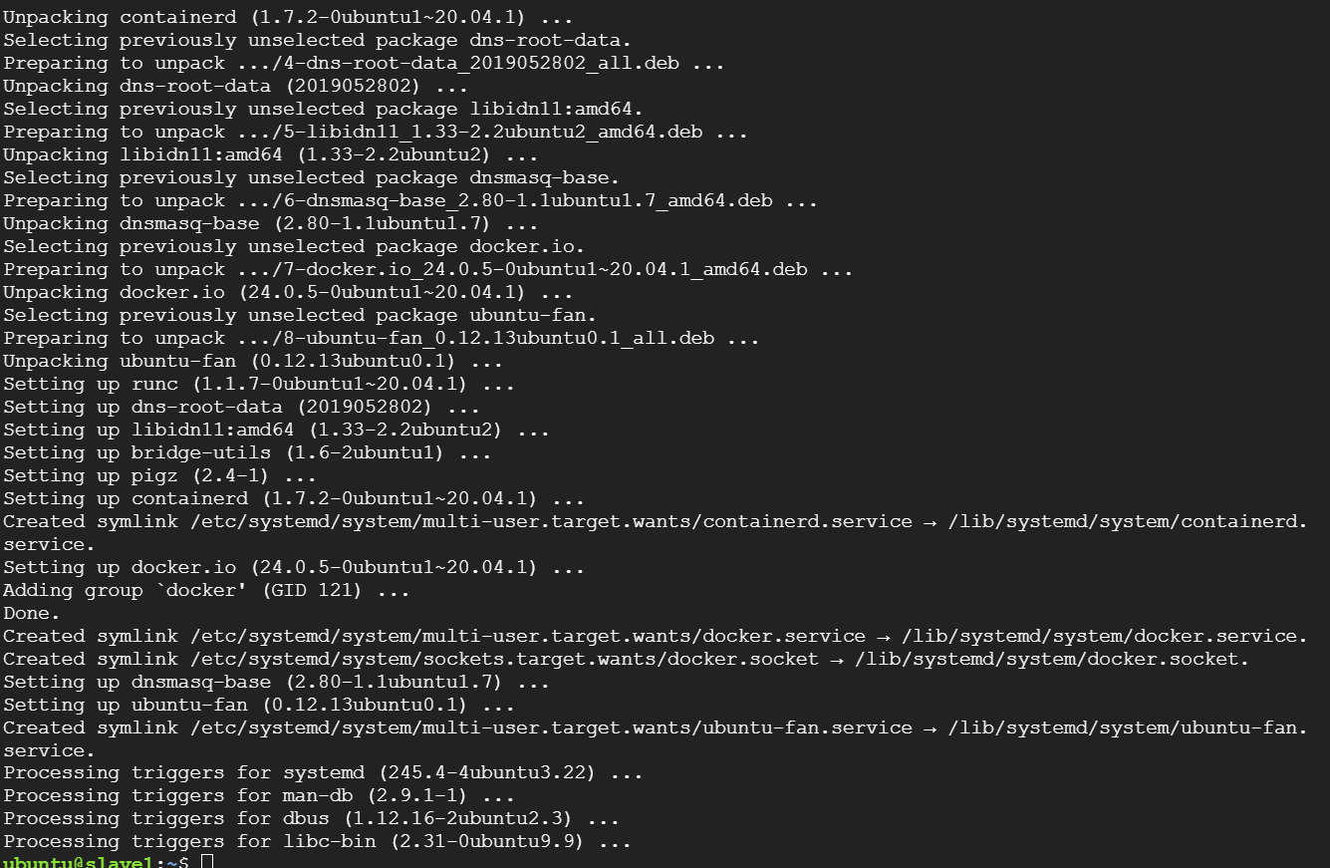

iii. Open Jenkins Dashboard. Create a new job (Freestyle Project) for Slave1.

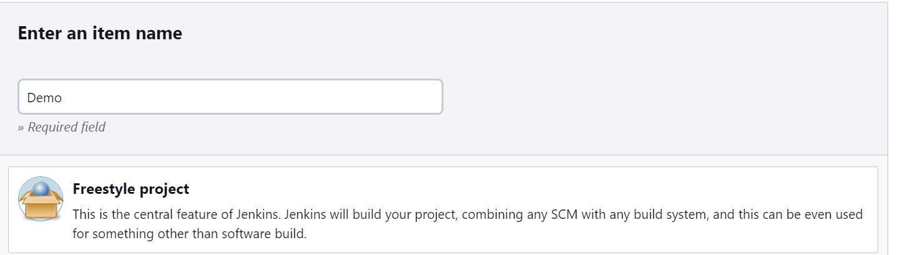

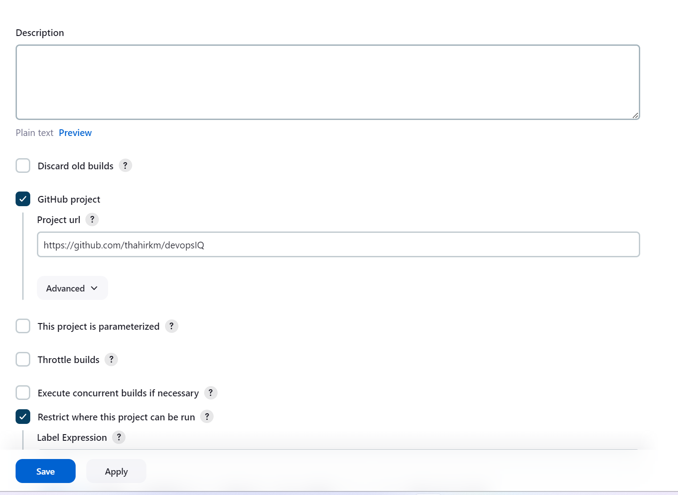

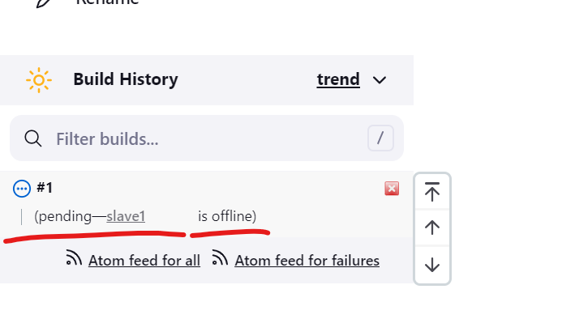

Please note that in my slave configuration to master was not successful because I can’t able to download agent.jar file to upload and make it as connected. I understood the way how we can integrate with pipeline and git. So please assist me to complete the lab with jenkins